**DAILY ONLINE ACTIVITIES SUMMARY**

|  |  |  |  |  |  |  |
| --- | --- | --- | --- | --- | --- | --- |
| **Date:** | **1-06-2020** | | | **Name:** | **B.A.SOHANKUMAR** | |
| **Sem & Sec** | **4TH SEM A** | | | **USN:** | **4AL18CS013** | |
| **Online Test Summary** | | | | | | |
| **Subject** | | **COMPLEX ANALYSIS , PROBABILITY AND STATISTICAL METHOD** | | | | |
| **Max. Marks** | | **30** | | **Score** | **29** | |
| **Certification Course Summary** | | | | | | |
| **Course** | **INTRODUCTION TO DATA STUDIO** | | | | | |
| **Certificate Provider** | | | **GOOGLE ANALYTICS ACADEMY** | **Duration** | | **4.5 HOURS** |
| **Coding Challenges** | | | | | | |
| **Problem Statement:1:Write a java program to calculate npr.**  **Problem Statement:2:Write a java program to find the distance between 2 points.** | | | | | | |
| **Status: EXECUTED** | | | | | | |
| **Uploaded the report in Github** | | | | **YES** | | |
| **If yes Repository name** | | | | **LOCKDOWN CODING** | | |
| **Uploaded the report in slack** | | | | **YES** | | |

**ONLINE TEST DETAILS:**

1. The test was from module 5 of COMPLEX ANALYSIS, PROBABILITY AND STATISTICAL METHOD (18MAT41).The duration of the test was 40 minutes from 9.30am to 10.10am.There were two rounds in test .First round was of 10 mcq 1 mark each and second round 10 mcq 2 mark each.The score I received is 29/30.



**CERTIFICATION COURSE DETAILS:**

**Course:** Introduction to DATA STUDIO

Today I have started with new course "INTRODUCTION TO DATA STUDIO".This course contains 4 modules each module containing 4 chapters.I have completed the 2 modules which contains Introduction to data studio,How data studio works, access controls, Creating Data studio home page and data source overview.And completed with 2 assessment test.



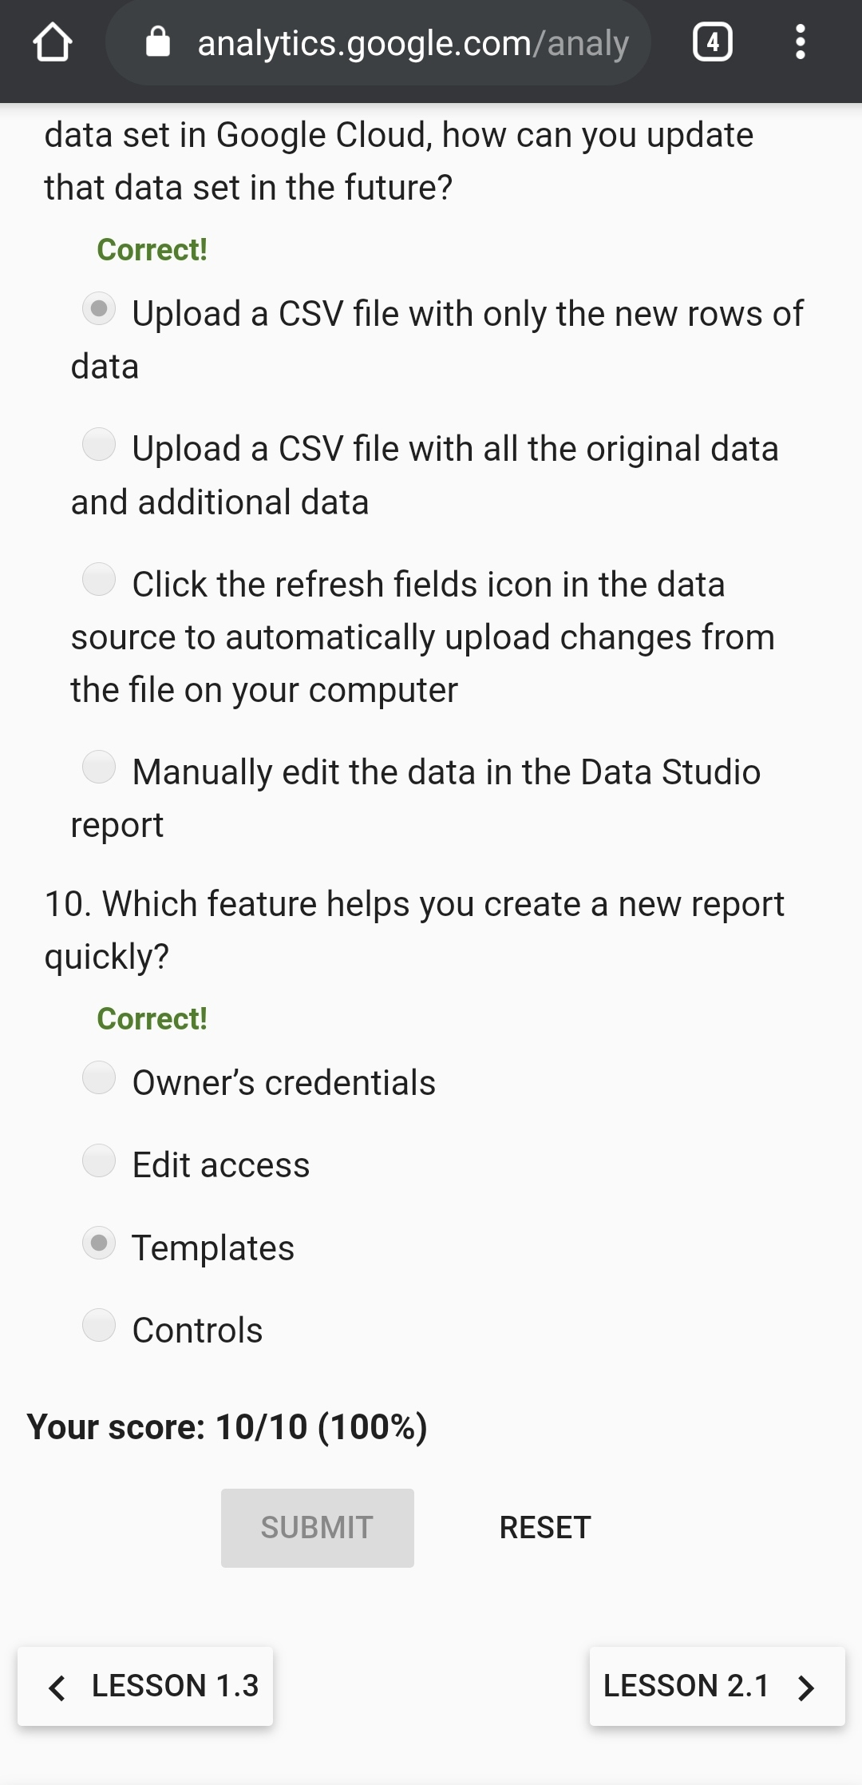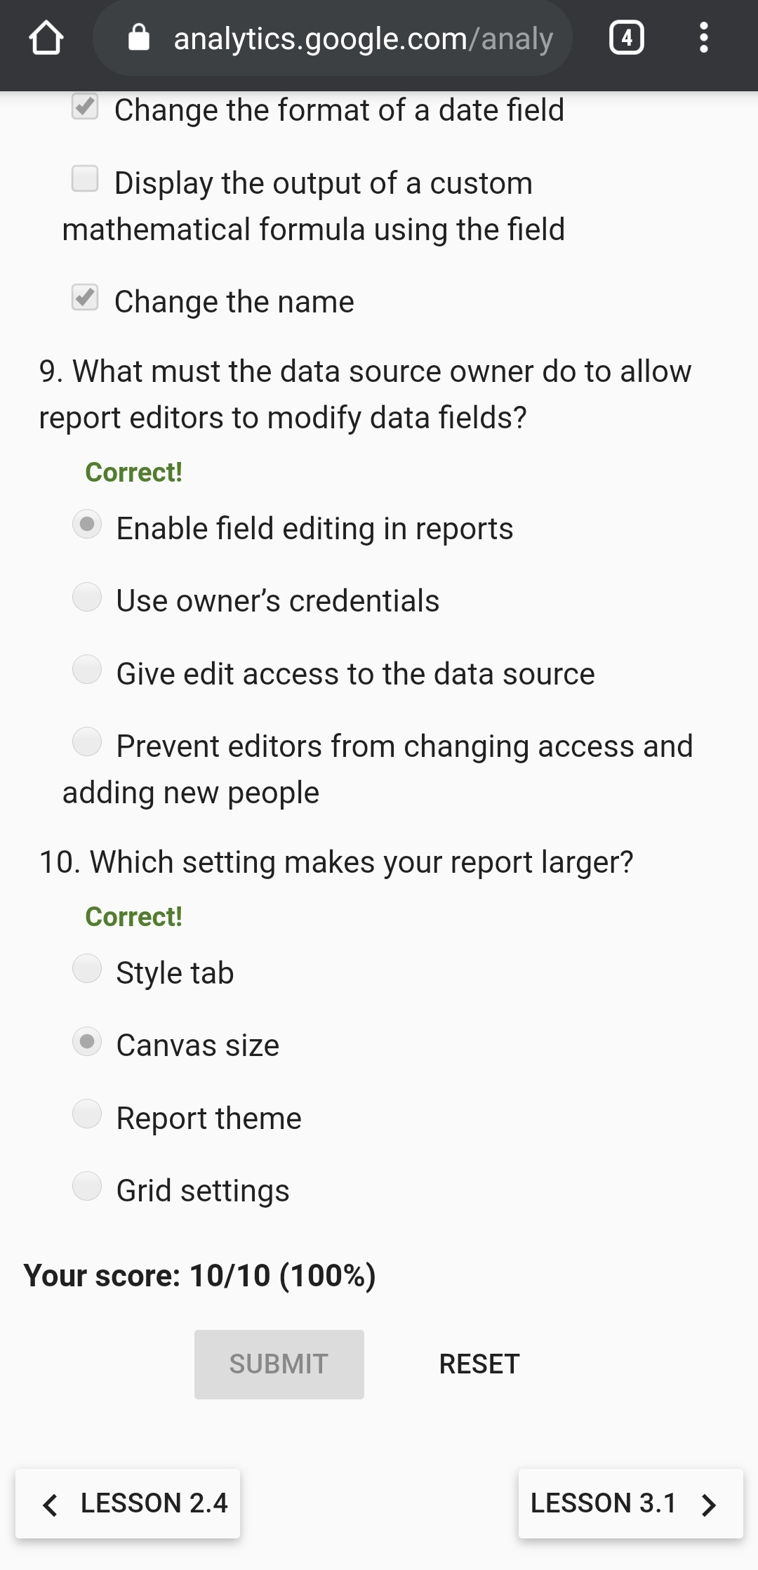

ASSESSMENT 1. ASSESSMENT 2.

**CODING CHALLENGES:**

1.**Write a java program to calculate npr.**

Input:The first line of the input contains T denoting the number of testcases. T testcases follow. First line of the test case will be the value of n and r respectively.

Output:For each test case, in a new line, output will be the value of nPr.

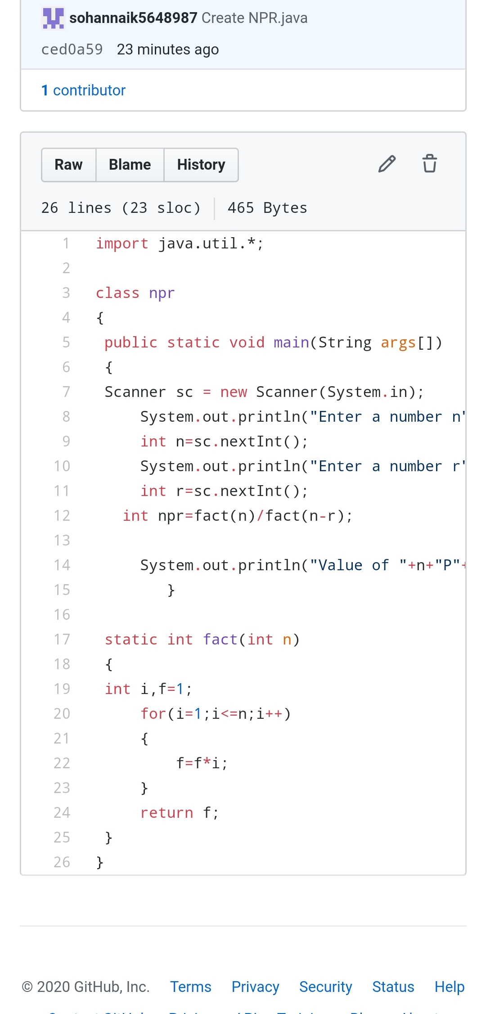

2.**Define a class Point with two fields x and y each of type double. Also , define a method distance(Point p1, Point p2) to calculate the distance between points p1 and p2 and return the value in double.. Use Math.sqrt( ) to calculate the square root.**

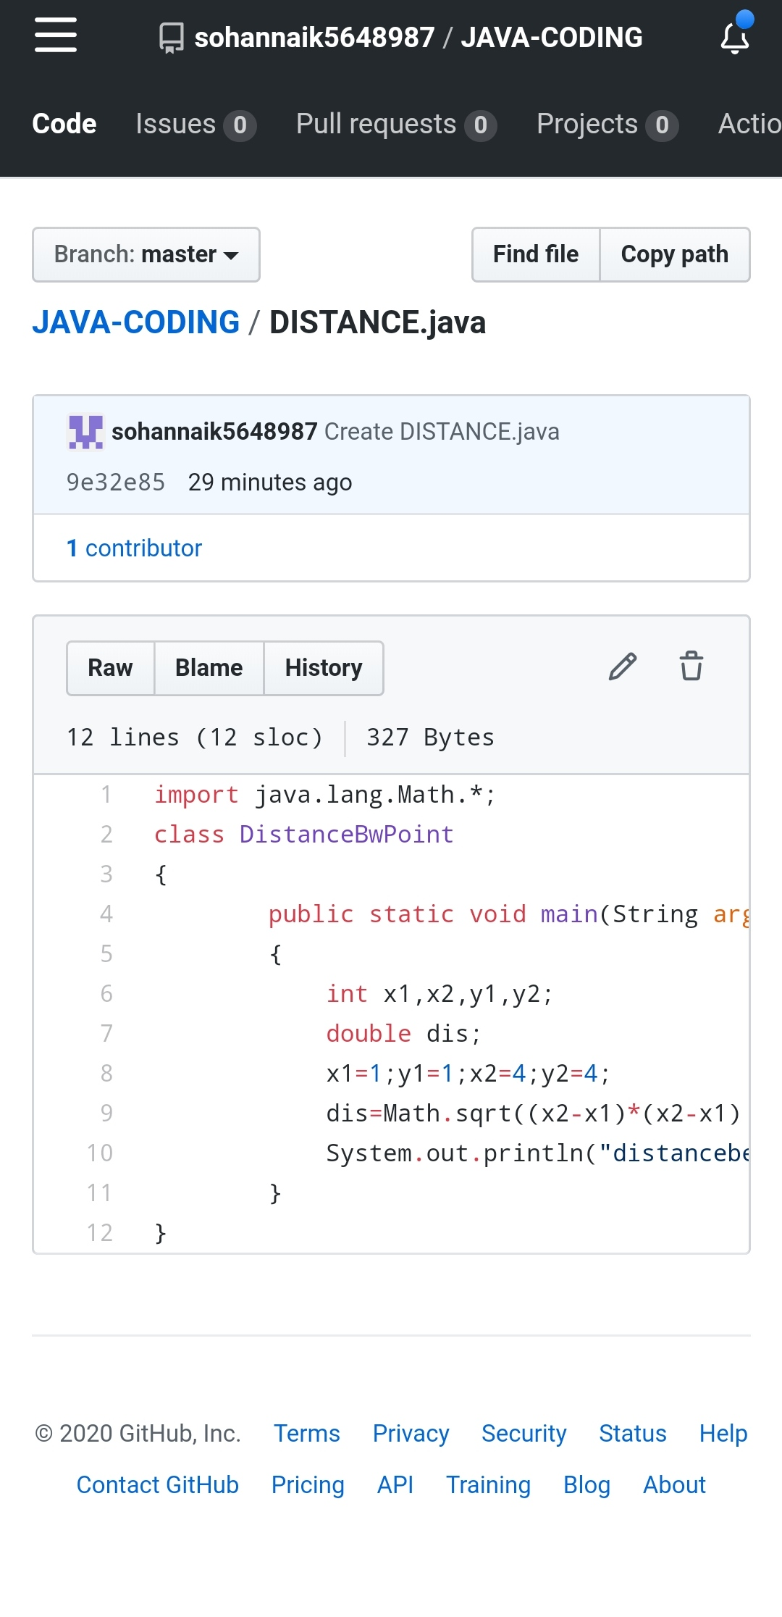

REPOSITORY LINK:https://github.com/sohannaik5648987/JAVA-CODING